Analysis of Gentiana data

**1. Relations between fitness components and reproductive traits - Differences in selection gradients among populations**

Linear models with type II sums of squares.

Fitness components (referred to the median shoot, NOT to the whole plant): using only the number of intact fruits (n_intact_fruits) because number of seeds cannot be calculated accurately for 2011 🡪 relativized to mean = 1 within each population (LokalID).

Reproductive traits: phenology index (phen_index, continuous, varies from 1 to 6, higher values indicate earlier flowering), state of the most advanced bud (most_adv, integer, varies from 1 to 6, higher values indicate earlier flowering), number of flowers (n_fl), number of shoots (n_shoots), height of the median shoot (h_shoot) 🡪 standardized to mean = 0 and sd = 1 within each population (LokalID).

Both measures of phenology (phen_index and most_adv) are strongly correlated (r = 0.86), so cannot include them at the same time in the models. We will show only analyses with most_adv, but state that we used the other measure and that the results were similar.

Removed populations with LokalID = Mar001, Sve001, Sve005 and Sve011 in 2011 because there is no information on fruits. Population with LokalID = Göt016 is colonized by the butterfly from 2010 to 2011.

|  |  |  |  |  |  |  |  |  |
| --- | --- | --- | --- | --- | --- | --- | --- | --- |
| Source of variation | 2010 | | | |  | 2011 | | |
| df | F | p | Estimate |  | df | F | p |
| Phenology (early flowering) | 1 | 0.05 | 0.827 |  |  | 1 | 0.47 | 0.493 |
| Flower number | 1 | 185.15 | <0.001 |  |  | 1 | 48.80 | <0.001 |
| Shoot number | 1 | 2.33 | 0.127 |  |  | 1 | 0.06 | 0.800 |
| Shoot height | 1 | 7.90 | 0.005 | 0.130 |  | 1 | 0.45 | 0.501 |
| Population x Phenology | 19 | 3.40 | <0.001 |  |  | 15 | 1.95 | 0.016 |
| Population x Flower number | 19 | 3.93 | <0.001 |  |  | 15 | 2.78 | <0.001 |
| Population x Shoot number | 19 | 1.18 | 0.267 |  |  | 15 | 0.68 | 0.802 |
| Population x Shoot height | 19 | 1.22 | 0.227 |  |  | 15 | 2.31 | 0.003 |

In both years, there are differences in selection gradients for phenology and flower number between populations. In 2010, the selection for higher shoots is constant between populations, while in 2011 there are differences between populations in the selection gradients for shoot height.

**2. Differences in selection gradients between populations with/without predator**

2010: 10 populations with predator / 10 without predator

2011: 11 populations with predator / 5 without predator

Selection gradients for each trait and population were calculated as the slope (beta-value) of the relationship between fitness and traits within that population.

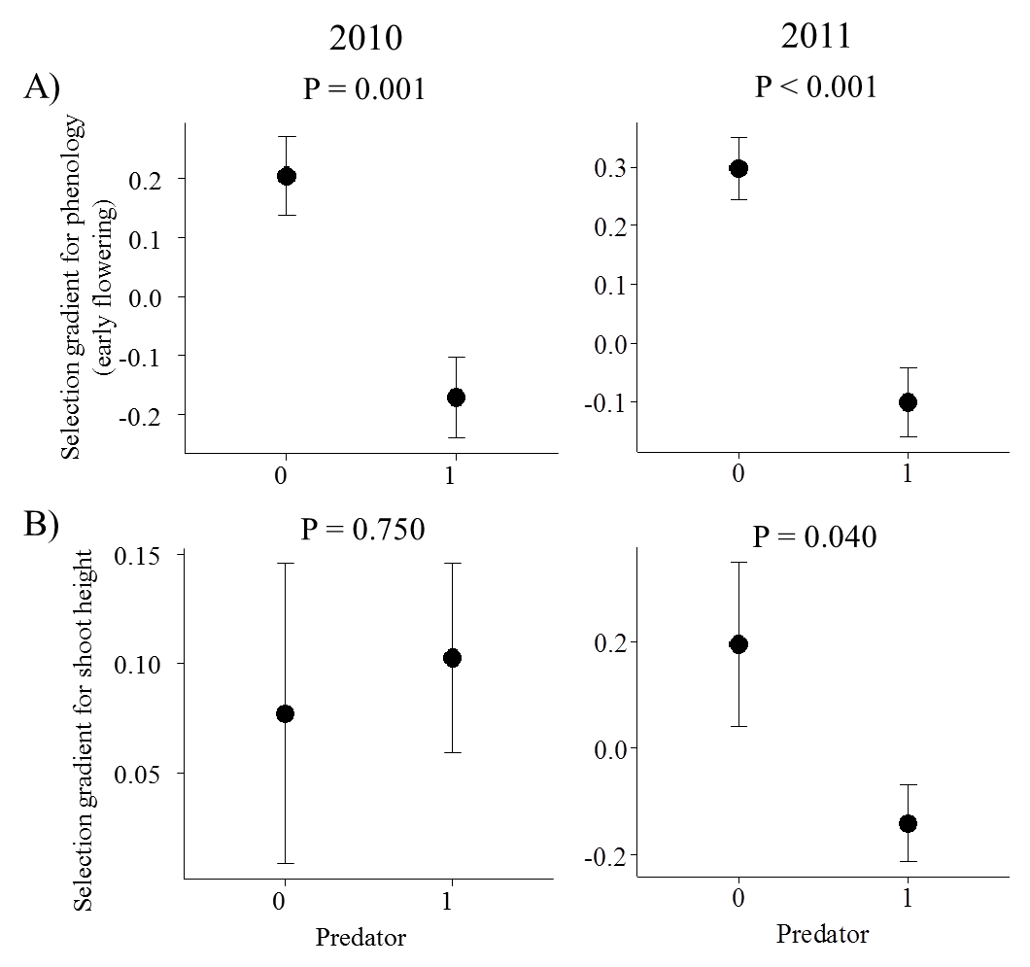

The selection gradients for phenology were different between populations with and without predator in both years. In populations where the predator is absent there was selection for earlier flowering (higher most_adv), while in populations where the predator was present there was selection for later flowering (lower most_adv).

In 2011 (but not in 2010), the selection gradients for shoot height were also different between populations with and without predator (coincident with the results of the previous models). In populations where the predator is absent there was selection for higher shoots, while in populations where the predator was present there was selection for lower shoots.

There were not any differences in selection gradients for the other traits (flower and shoot number) between populations with and without predator.

**3. Variation in selection gradients with predation intensity**

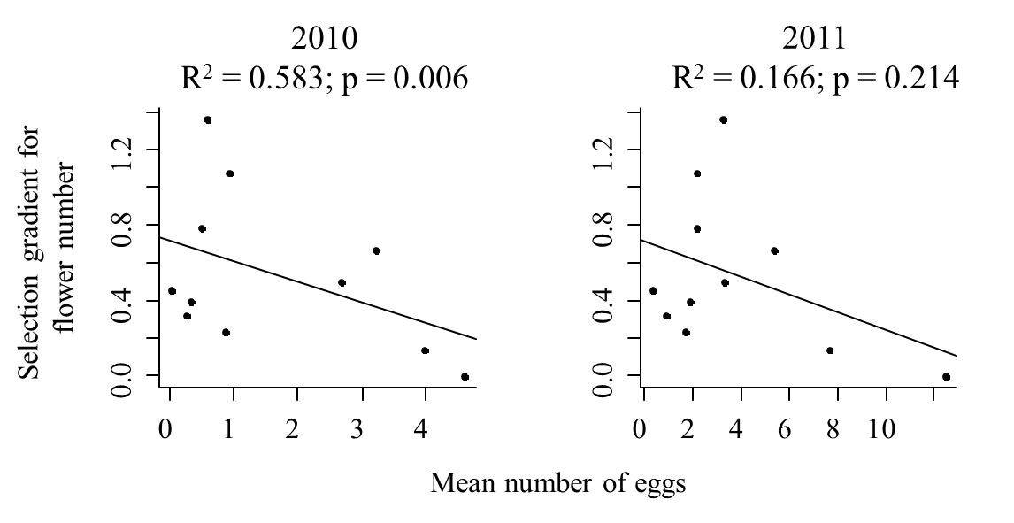

Selection gradient for flower number is significantly related to interaction intensity measured as mean number of eggs per population (considering the 11 populations where the predator was present) in 2010. Populations with higher intensity of predation (higher number of eggs) show selection for lower number of flowers. There is, however, no relation between intensity of predation (measured as mean number of eggs) and selection gradient for phenology.

In 2011, the selection gradient for flower number is not related to interaction intensity measured as mean number of eggs per population.

**4. Effects of traits on interaction intensity**

(in 11 populations where the predator is present) – y = n_eggs

|  |  |  |  |  |  |  |  |
| --- | --- | --- | --- | --- | --- | --- | --- |
| Source of variation | 2010 | | |  | 2011 | | |
| df | F | p |  | df | F | p |
| Phenology (early flowering) | 1 | 60.98 | <0.001 |  | 1 | 39.41 | <0.001 |
| Flower number | 1 | 72.47 | <0.001 |  | 1 | 243.94 | <0.001 |
| Shoot number | 1 | 1.05 | 0.307 |  | 1 | 0.07 | 0.784 |
| Shoot height | 1 | 0.00 | 0.950 |  | 1 | 0.00 | 0.997 |
| Population | 10 | 36.11 | <0.001 |  | 10 | 46.00 | <0.001 |
| Population x Phenology | 10 | 10.68 | <0.001 |  | 10 | 4.39 | <0.001 |
| Population x Flower number | 10 | 9.18 | <0.001 |  | 10 | 32.59 | <0.001 |
| Population x Shoot number | 10 | 1.04 | 0.404 |  | 10 | 1.12 | 0.345 |
| Population x Shoot height | 10 | 0.69 | 0.731 |  | 10 | 0.64 | 0.781 |

In both years, selection on phenology and flower number seems to be in part determined by the intensity of predation.

The relationship between the number of eggs and phenology and between number of eggs and flower number varied among populations.

Variation of the relationship between the number of eggs and phenology among populations:

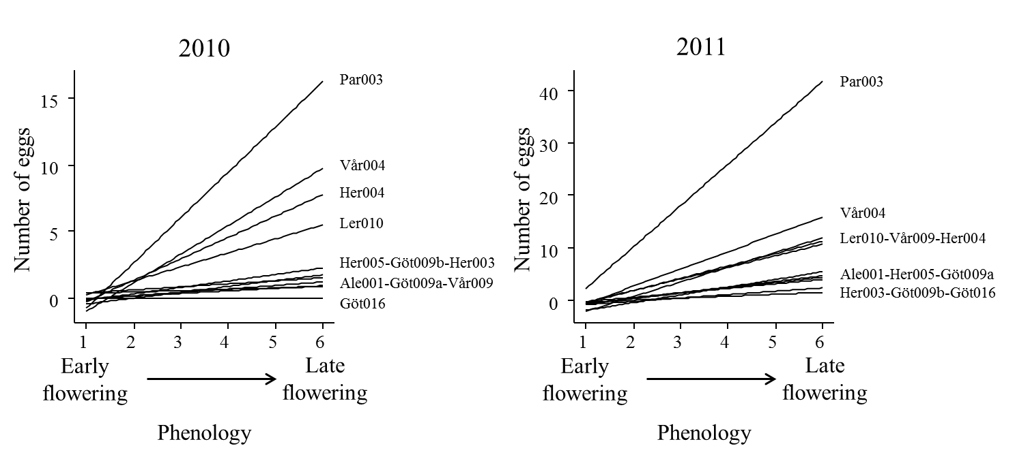

**5. Ants**

We can see the effects of ant abundance on predator presence with a logistic regression.

Abundance of ants in both years is strongly correlated. The population Mar001 is an outlier, with no butterflies but with high number of ants in both years (this population was removed from previous analyses in 2011 because there were no data on fruits and seeds, but kept here).

Using the maximum ant abundance for both years, and including population Göt016 as predation = 1, there is a significant relationship between butterfly presence and ant abundance:

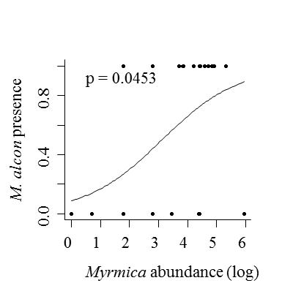

There is also a positive relation with patch area